**Week 7: List**

**Part A:** **List**

1. Generate the output from the following program. Understand how the program works.

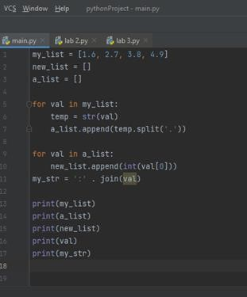

**Mutable List**

1. List is mutable, write a program to generate the given output.

(**Hint1**: Try to code several alternatives way to generate the same generated output for [‘bye’, ‘mother’, ‘dad’, [‘halmeoni’, ‘grandpa’]]. **Hint2**: Using the same list, try to code to change the original list into [‘hi’, ‘mom’, ‘father’, [‘halmeoni’, ‘grandpa’]]

**Output sample:**

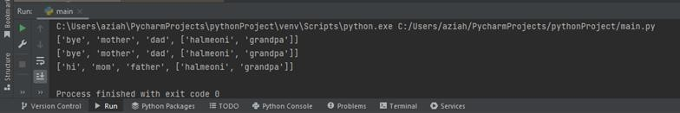

1. Given numList = [1,3,5,5,2]. Write a program that:
   1. Sorts the list.
   2. Adds 4 at the end of the list
   3. Remove on duplicate
   4. Inserts 6 at index 4
   5. Print the number of items in the list.

**Part B:** Test yourself!

1. Write a Python code to create a list number using these number = 65, 75, 85, 95, 105 and check number that prompt the user to enter a number to check that number is available or not in list.
2. Write a Python program to shuffle and print a specified list.

food = [“cookies”, “brownies”, “cake”, “ice cream”, “chocolate”]

3. Write a Python program to get the difference between the two lists.

4. Write a Python program to convert a list of characters into a string.

5. Write a Phyton program to generate the expected output as below:

Given list is [100, 200, 300, [“turmeric”, “galanga”, [“kiwi”, “apple”, “oranges”]], 50, 60, 70]

**Expected output:**

1. apple
2. [300, ['turmeric', 'galanga', ['kiwi', 'apple', 'oranges']]] [50, 60, 70]
3. [100, 200, 300, ['turmeric', 'galanga', ['kiwi', 'apple', 'oranges']], 50, 60, 70, 'kiwi', 'apple', ‘oranges]